1. Construct by hand a Perceptron which correctly classifies the following data; use your knowledge of plane geometry to choose appropriate values for the weights w0, w1 and w2. 5

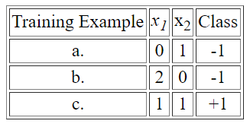

1. Demonstrate the Perceptron Learning Algorithm on the above data, using a learning rate of 1.0 and initial weight values of

*w0* = -1.5  
*w1* =   0  
*w2* =   2

In your answer, you should clearly indicate the new weight values at the end of each training step. 10